2026 GLOBAL PUBLISHING IP BUSINESS MEETING | EXPANDED RIGHTS CATALOGUE
BOOK 01  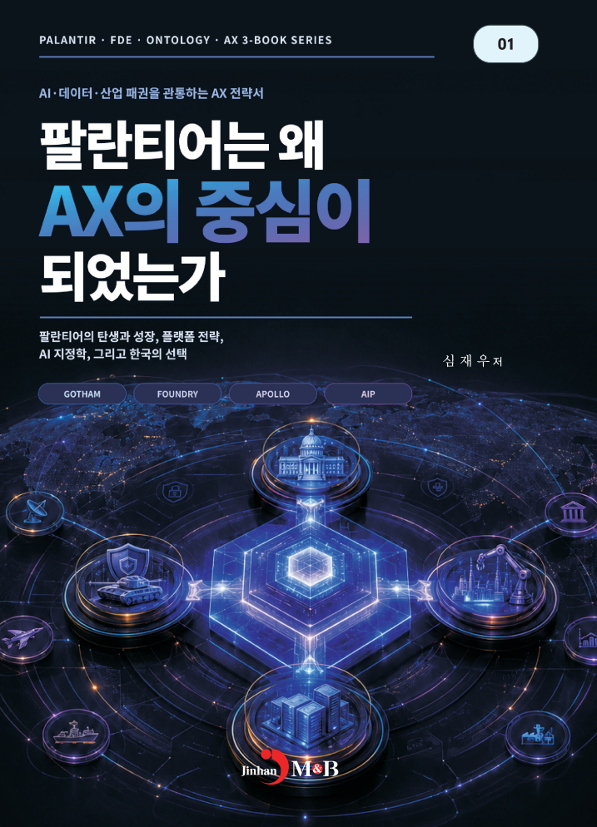  KOREAN ORIGINAL  Publisher Jinhan M&B  Author Shim Jae Woo  Foreign-language rights  Available for discussion | Why Did Palantir Become the Center of AX?  AI · Data · Industry Transformation · AX Strategy  BOOK POSITIONING A strategic introduction to the question every organization now faces: how can artificial intelligence move from demonstrations and isolated tools to a system that changes decisions, operations, and competitive performance?  EDITORIAL OVERVIEW  Using Palantir’s rise and platform strategy as a starting point, this title explains AX as a business and operating transformation rather than a simple technology purchase. The book brings together AI, data, organizational decision-making, and industrial execution in a form accessible to business readers.  Its central value is perspective. Readers are invited to see data not as a technical resource held by IT teams, but as a shared basis for acting across the enterprise. This makes the title relevant to leaders who must connect corporate strategy with frontline execution.  REPRESENTATIVE CONTENT THEMES  • Palantir’s emergence, growth, and platform-centered strategy  • The relationship between AI, data, operations, and industrial competitiveness  • AI geopolitics and the strategic choices facing organizations and nations  • How to convert fragmented information into decision and execution capacity  • A Korean viewpoint on the future of AX and business transformation  TARGET READERS CEOs, executives, strategy leaders, digital transformation teams, consultants, MBA and executive education readers.  EXPORT AND LOCALIZATION OPPORTUNITY An accessible lead title for a business publisher seeking a timely AI-and-management book. A local edition can add a foreword, an editor’s note, or selected domestic cases to align with the target market.  RIGHTS AND MATERIALS Simplified Chinese, Traditional Chinese, English, and other language rights may be discussed with the publisher. Translation sample, full table of contents, and manuscript materials can be supplied on request.
RIGHTS INQUIRIES | Jinhan M&B | Author: Shim Jae Woo | 2026 Global Publishing IP Business Meeting

2026 GLOBAL PUBLISHING IP BUSINESS MEETING | EXPANDED RIGHTS CATALOGUE
BOOK 02  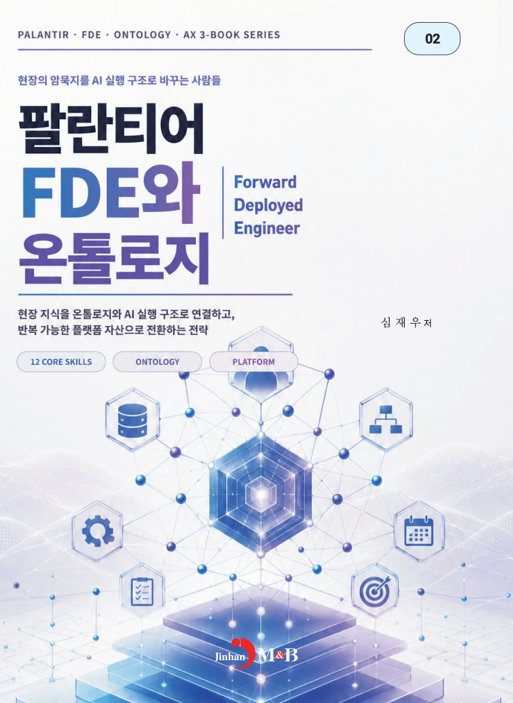  KOREAN ORIGINAL  Publisher Jinhan M&B  Author Shim Jae Woo  Foreign-language rights  Available for discussion | Palantir FDE and Ontology  FDE · Ontology · AI Execution · Organizational Capability  BOOK POSITIONING A practical concept book for organizations that need more than AI tools: they need people who can discover field problems, connect expertise with data, and build an operating structure that produces measurable outcomes.  EDITORIAL OVERVIEW  This title introduces the Forward Deployed Engineer, or FDE, as a field-based problem solver who connects business teams, domain expertise, data, software, and decision-makers. It expands the conversation beyond the narrow idea of a developer dispatched to a customer site.  It also explains ontology as the shared language through which people, data, rules, events, and actions can be connected. The result is a framework for turning tacit operational knowledge into reusable assets for AI-enabled work.  REPRESENTATIVE CONTENT THEMES  • FDE as a translator between frontline work, data, technology, and leadership  • Ontology as a shared language for objects, relationships, rules, and actions  • From one-off AI projects to reusable organizational and platform assets  • Core capabilities required for field-based AI execution  • The human and organizational conditions for AI adoption to create results  TARGET READERS AI project leaders, enterprise architects, consultants, technology managers, innovation teams, and university or executive education readers.  EXPORT AND LOCALIZATION OPPORTUNITY A differentiated title for publishers following the fast-growing global conversation on AI implementation talent, enterprise ontology, and digital transformation. It can stand alone or anchor a three-book AX series.  RIGHTS AND MATERIALS Simplified Chinese, Traditional Chinese, English, and other language rights may be discussed with the publisher. Translation sample, full table of contents, and manuscript materials can be supplied on request.
RIGHTS INQUIRIES | Jinhan M&B | Author: Shim Jae Woo | 2026 Global Publishing IP Business Meeting

2026 GLOBAL PUBLISHING IP BUSINESS MEETING | EXPANDED RIGHTS CATALOGUE
BOOK 03  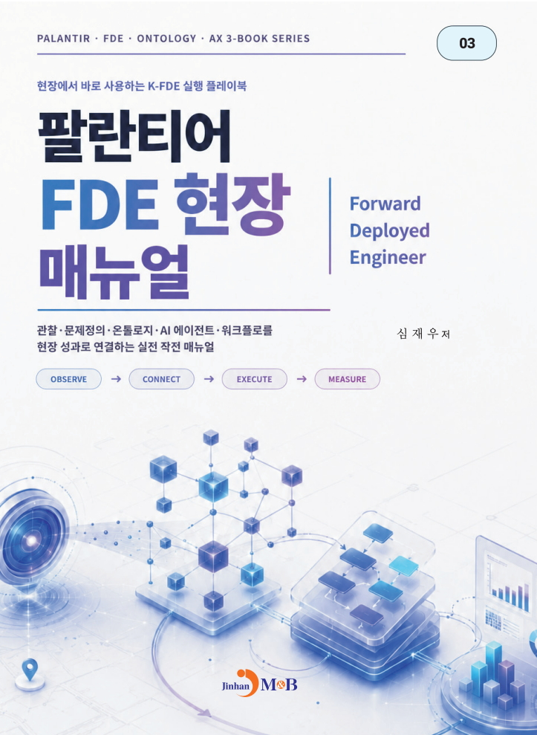  KOREAN ORIGINAL  Publisher Jinhan M&B  Author Shim Jae Woo  Foreign-language rights  Available for discussion | Palantir FDE Field Manual  Field Playbook · Workflow · AI Agent · KPI Execution  BOOK POSITIONING A field-oriented playbook for turning AI ambition into an operating sequence: observe the real problem, connect people and information, execute a working solution, and measure the outcome.  EDITORIAL OVERVIEW  The title provides a practical FDE-style frame for linking field observations, business problems, ontology, AI agents, workflows, and performance indicators. Its focus is not on technology for its own sake, but on proving whether behavior and measurable results have changed in the field.  The manual is designed to be useful to practitioners and educators alike. It supports the building of execution capability through small experiments, documented learning, repeatable workflows, and cross-functional collaboration.  REPRESENTATIVE CONTENT THEMES  • Observe → Connect → Execute → Measure as an execution cycle  • Problem discovery and field observation before solution design  • Connecting ontology, AI agents, and workflow design to operating decisions  • Small experiments, validation, and KPI-based learning  • Turning successful field practice into a repeatable team asset  TARGET READERS FDE candidates, enterprise innovation teams, consultants, managers, vocational and higher education programs, and corporate training participants.  EXPORT AND LOCALIZATION OPPORTUNITY A hands-on companion title suited to corporate learning, university courses, consulting programs, and workshop editions. It can be localized with worksheets, local cases, and a market-specific training guide.  RIGHTS AND MATERIALS Simplified Chinese, Traditional Chinese, English, and other language rights may be discussed with the publisher. Translation sample, full table of contents, and manuscript materials can be supplied on request.
RIGHTS INQUIRIES | Jinhan M&B | Author: Shim Jae Woo | 2026 Global Publishing IP Business Meeting

2026 GLOBAL PUBLISHING IP BUSINESS MEETING | EXPANDED RIGHTS CATALOGUE
BOOK 04    KOREAN ORIGINAL  Publisher Jinhan M&B  Author Shim Jae Woo  Foreign-language rights  Available for discussion | Why Couldn’t Zhuge Liang Build an FDE Organization?  Three Kingdoms · Leadership · Talent · AI-era Organization  BOOK POSITIONING A contemporary management book that uses the familiar world of the Three Kingdoms to ask a decisive AI-era question: how can exceptional individual problem-solving become a sustainable organizational capability?  EDITORIAL OVERVIEW  The book reinterprets people and events from the Three Kingdoms through the lenses of future talent, leadership, ontology, and FDE-style execution. It treats the historical narrative not merely as a tale of heroes, but as a rich laboratory of people, resources, alliances, rules, decisions, and action.  Its central question is deliberately provocative. Zhuge Liang can be read as an extraordinary problem solver, yet Shu Han did not fully become an organization that continually developed comparable integrative problem solvers. The book turns that tension into a practical question for today’s leaders.  REPRESENTATIVE CONTENT THEMES  • Zhuge Liang as a modern metaphor for an exceptional FDE-style problem solver  • The difference between a great individual and a system that develops successors  • Three Kingdoms figures and events reinterpreted through talent, organization, and execution  • Ontology as a way to connect people, events, resources, rules, and action  • AI-era future talent: problem definition, field understanding, collaboration, and results  TARGET READERS General business readers, leadership readers, Three Kingdoms readers, educators, young professionals, and organizations developing future talent.  EXPORT AND LOCALIZATION OPPORTUNITY The strongest China-facing lead title in the portfolio. It combines cultural familiarity with an original management argument and can expand into leadership education, youth content, digital learning, and cross-media IP discussions.  RIGHTS AND MATERIALS Simplified Chinese, Traditional Chinese, English, and other language rights may be discussed with the publisher. Translation sample, full table of contents, and manuscript materials can be supplied on request.
RIGHTS INQUIRIES | Jinhan M&B | Author: Shim Jae Woo | 2026 Global Publishing IP Business Meeting

